The goal of this assignment was to understand how to recursively call functions. The user input that the program reads is what the name of the text file is. The program will read that text file with a maze on it and the program will try to solve the maze. The only error checking that is used is to make sure that whatever the user typed in matches what’s in the directory.

The maze that is used in the text file is the one from the assignment sheet at the top. The maze from the text file is read in as a 2D array of characters with certain characters being used for walls, spaces, and paths. Once the maze is read in that program try to solve this by using functions that call each other. The one function, solve(), is what’s called inside the main function and it is from there that the recursion begins. The only thing that can be seen as a con would be just how much recursion is used.

Sample code was provided in the form of the main function and the skeletons of other functions. I cannot think of any changes that would need to be made to the program to extend or adapt it. Development time took the full two weeks.

There were no problems with the testing process however the desired output was not achieved. The program would find the entry point to the maze but there would be no way to make that entry point seen. Special cases that were tested were if there were no entry points and if there was no solution, which the program passed the former but not the latter. Pictures of these two outputs are shown below.

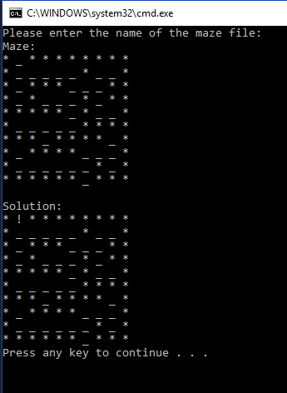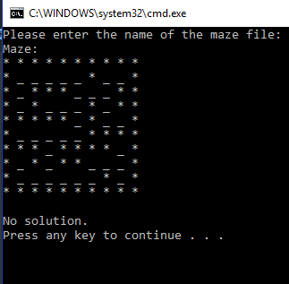

Figure Output when there isn't a solution

Figure Maze with no entry points

The overall results of the program did not go as I would have like them to. I would label this program a success but it did teach how to do proper recursion. If this assignment were to be done again I would allow for more time for this to be completed.